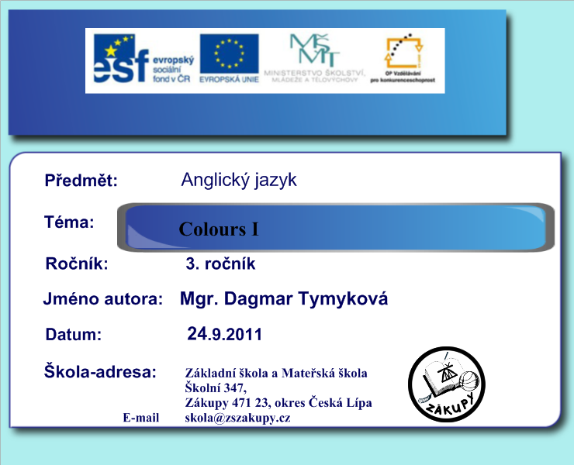

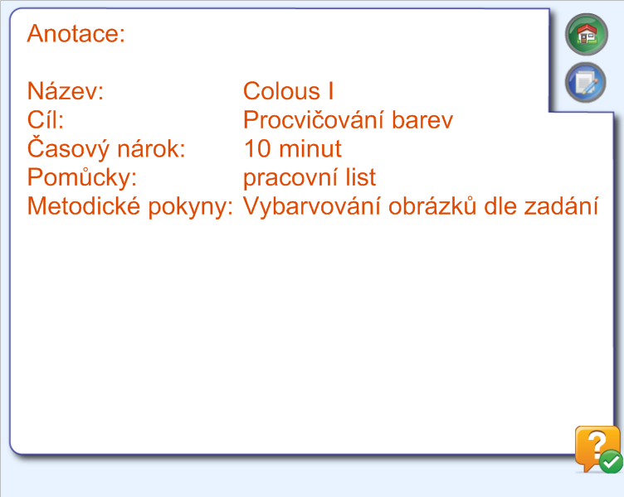

1. The chicken is yellou. 5. The snowman is white.
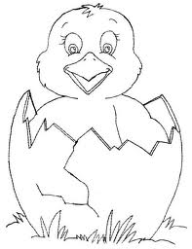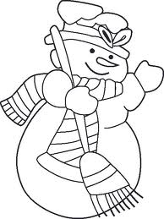
2. The apple is green. 6. The potato is brown.
3. The stawberry is red. 7. The orange is orange.
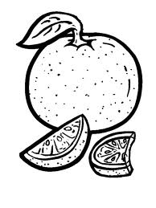
4. The cloud is blue. 8. The sweep is black.
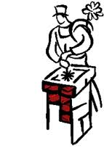

Použité zdroje
- obrázky z web. stránek
1.obr.-kuře http://www.google.cz/imgres?q=ku%C5%99e&hl=cs&sa=X&biw=923&bih=641&gbv=2&tbs=itp:lineart&tbm=isch&tbnid=X2p7GAUci0erKM:&imgrefurl=http://malovaneobrazky.blog.cz/galerie/sablony-na-sklo/obrazek/63469189&docid=Ab3w1zj8KgbikM&w=559&h=726&ei=2C93TvXmNovDtAbI_rW_Dg&zoom=1
2. obr. Sněhulák http://www.google.cz/imgres?q=sn%C4%9Bhul%C3%A1k&hl=cs&biw=923&bih=593&gbv=2&tbs=itp:lineart&tbm=isch&tbnid=8dAvlyMkItfetM:&imgrefurl=http://auto-moto-samolepky.afirma.cz/?p=productsMore&iProduct=1372&docid=b4CuB8FjNJg1fM&w=500&h=666&ei=YzR3Tu7UCNH0sgaow5zSCw&zoom=1
3. obr. Jablko http://www.google.cz/imgres?q=jablko&hl=cs&gbv=2&biw=923&bih=592&addh=36&tbs=itp:lineart&tbm=isch&tbnid=HelQ5Js4J2zwWM:&imgrefurl=http://lazypeacock.blogspot.com/2010/10/apple-day.html&docid=YEDjWe5MoyPPdM&w=690&h=773&ei=1TB3TpSzHYPMswaut4W6Cw&zoom=1
4. obr. Brambory http://www.google.cz/imgres?q=brambora&hl=cs&biw=923&bih=593&gbv=2&tbs=itp:lineart&tbm=isch&tbnid=FXoW1sJe21QbpM:&imgrefurl=http://de.dreamstime.com/stockfotos-gem-seserie-kartoffeln-image5417903&docid=7W6LA-ddK2SrVM&w=300&h=238&ei=bjJ3ToqiEYvMtAbWpYiJCw&zoom=1
5. obr. Jahoda http://www.google.cz/imgres?q=jahoda&hl=cs&biw=923&bih=592&gbv=2&tbs=itp:lineart&tbm=isch&tbnid=nSUPwjcjKZqNXM:&imgrefurl=http://www.sherriallen.com/coloring/fruit.html&docid=L75yFgi34vG27M&w=540&h=720&ei=OzF3Ts7ZCM_Hsgb1v5zQCw&zoom=1
6. obr. Pomeranč http://www.google.cz/imgres?q=pomeran%C4%8D&hl=cs&biw=923&bih=593&gbv=2&tbs=itp:lineart&tbm=isch&tbnid=2M0J8iXDvEdJuM:&imgrefurl=http://www.i-creative.cz/2009/11/23/citron-a-pomeranc-omalovanky/&docid=TWEhDocBUIu65M&w=599&h=799&ei=wjN3TvvsOcbPsgaD0MSoDg&zoom=1
7. obr. Mrak http://www.google.cz/imgres?q=mrak&hl=cs&biw=923&bih=593&gbv=2&tbs=itp:lineart&tbm=isch&tbnid=Lorrut3D_F3lrM:&imgrefurl=http://berusci.net/obrazky/mrak&docid=myM-ejEEMfKkrM&w=488&h=400&ei=kjF3TtOUHMTcsgaQmqCSCw&zoom=1
8. obr. Kominík http://www.google.cz/imgres?q=komin%C3%ADk&hl=cs&biw=923&bih=593&gbv=2&tbs=itp:lineart&tbm=isch&tbnid=KogiYboXs08AsM:&imgrefurl=http://www.kominictvi-komtic.cz/kontakt.html&docid=N2AiZgEuZLJxmM&w=179&h=268&ei=tDR3TvO0O4v1sgbhkNiQCw&zoom=1

