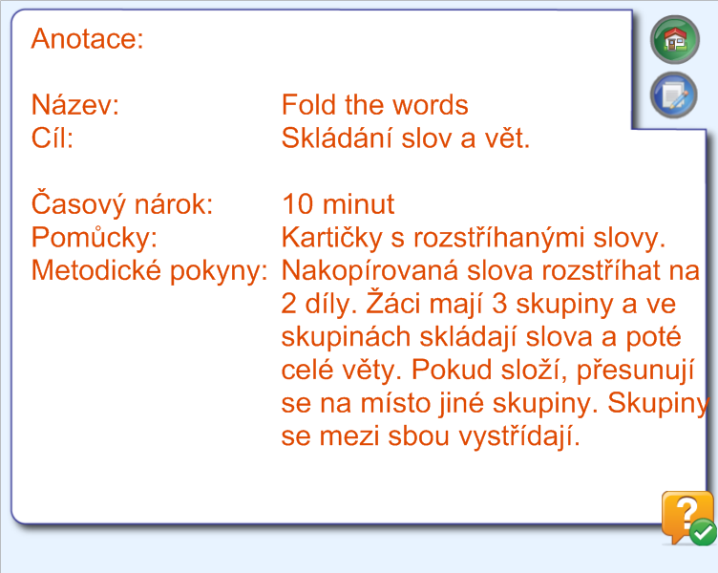

Hello. Goodbye bye.
What´s your name?

Hello. Goodbye bye.
Do you like Fish?

Hello. Goodbye bye. Where are you from?

