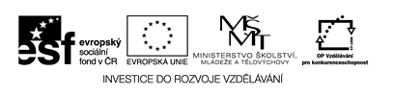
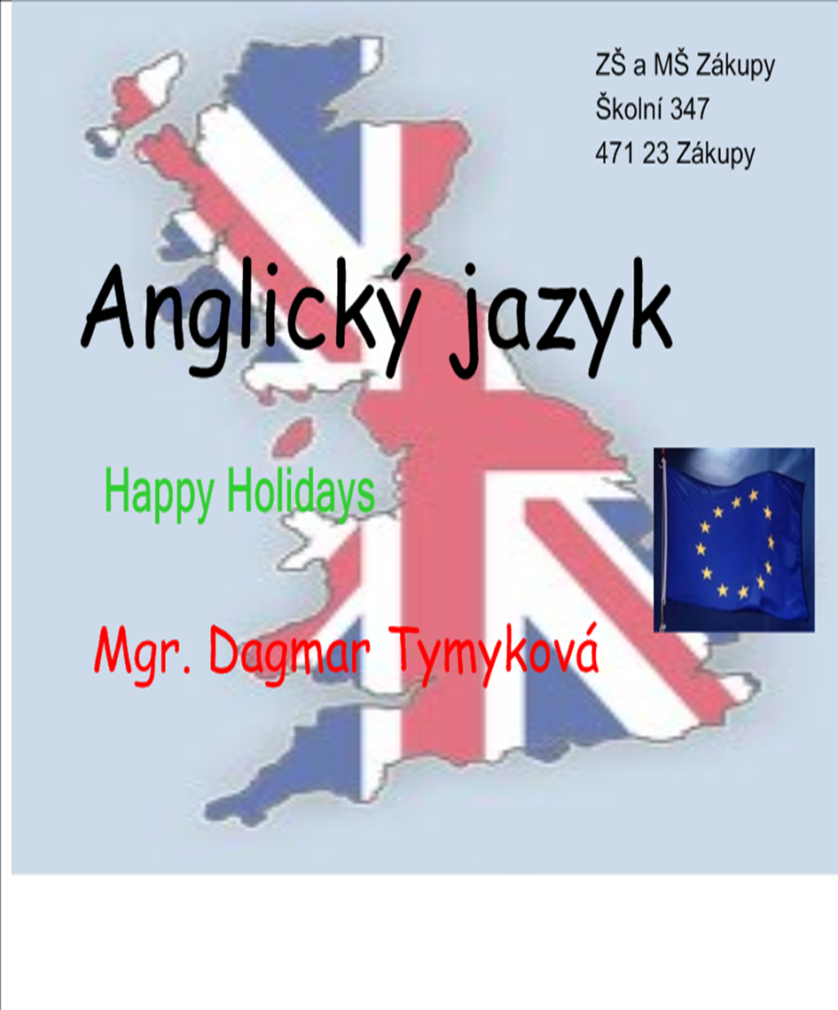

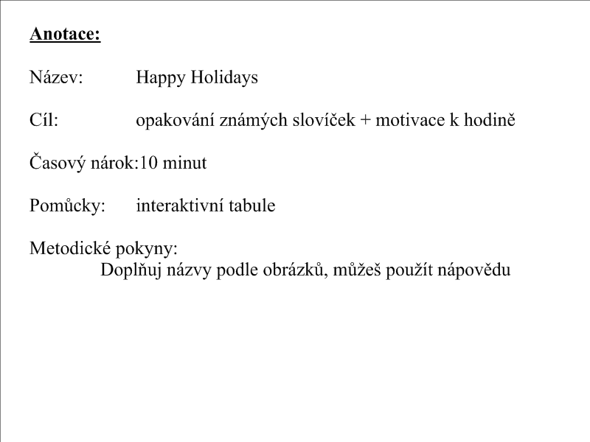

Crosword
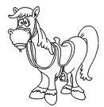 | 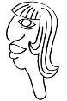 | 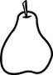 | 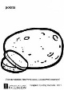 | 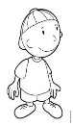 |  | 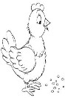 | 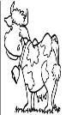 | 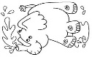 | 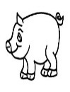 | 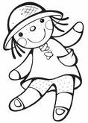 | 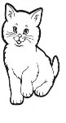 |  | 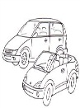
* | * | * | * | * |  | * | * | * | * | * | * | *
* | H | * | * |  |  | * | * | * | * | * | * | *
* |  | * | * |  |  | C |  |  |  | * |  | * | R
 |  |  |  |  | *
 |  | E | O |  |  |  | W
R |  |  |  |  |  |  |  |  |  | L
 |  |  |  |  |  |  |  | H
 |  |  |  |  |  |  |  |  |  |  |  | W
 |  |  | S
Nápověda:
Yellow, doll, hors, pear, chicken, head, potatoes, cow, elephant, cat, pig, boy, cars

