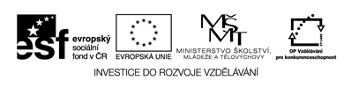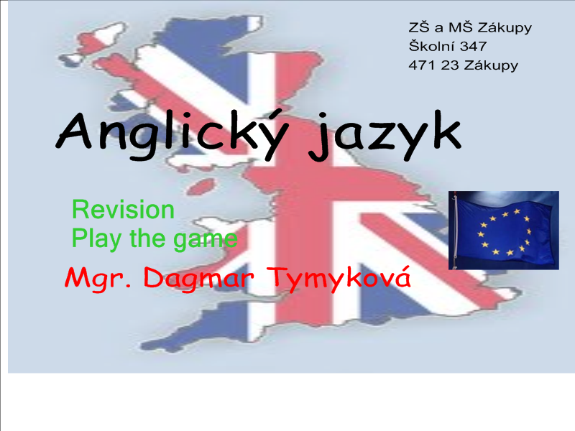

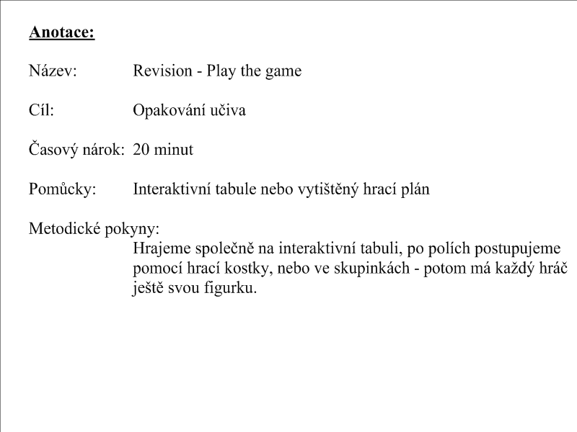

Hrací plán

→Start | How are you? | 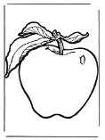 | 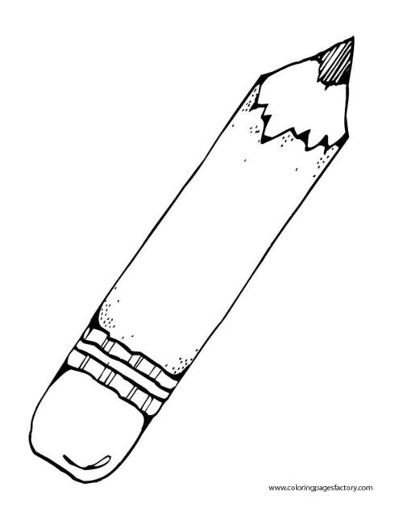 | What is your name? | Back 2  ← | 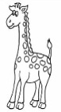 |  | Point to window |  |  | Do you like hot dog? |  | 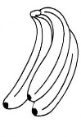
Back 1
↑
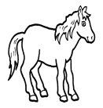 | What´s your name? | 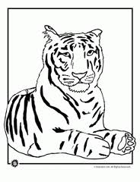 | 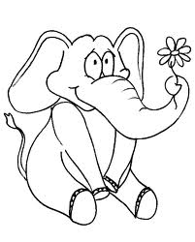 | Back 3  → | How old are you? | 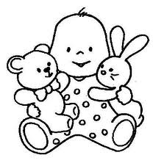 |  | What colour? |  |  | 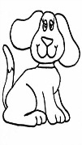 |  | Where are you from?
What colour?

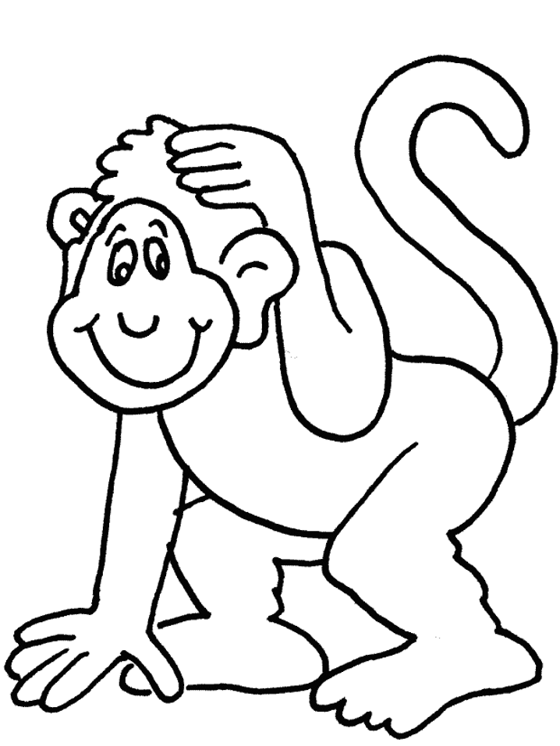 | What´s your name? | 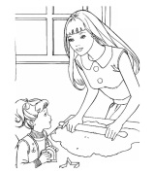 | Do you like banana? | Jumb! | 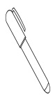 | What colour? |  | Point to red colour. |  | Back 5  ← |  |  | How are you?
 |  |  |  |  |  |  |  |  |  |  |  |  | 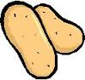
Stend up! | 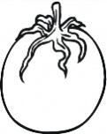 | 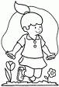 | Shake your hand! | 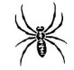 | Kick your leg! |  | 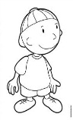 |  | Do you like onion? |  |  | 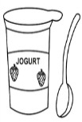
Back 8
↑

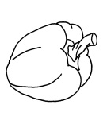 | 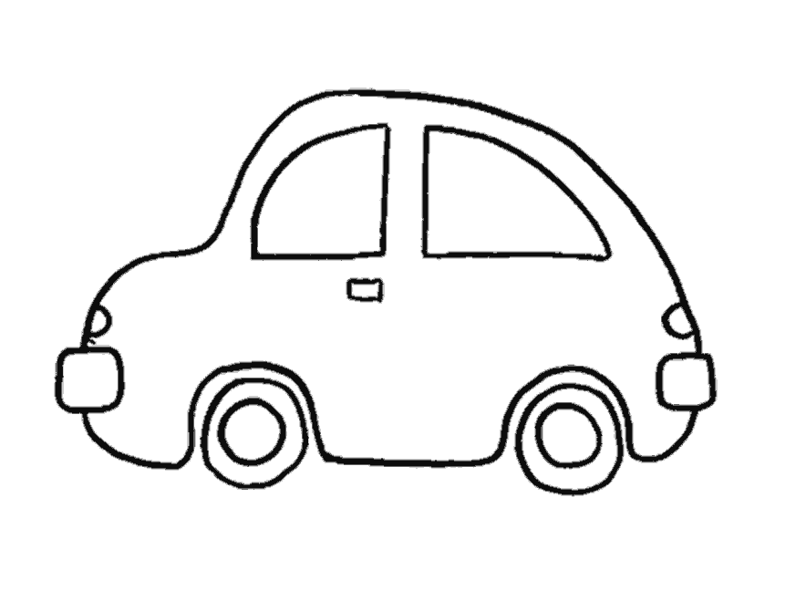 | Point to teacher. | Clap your hand! | What colour? |  | Sleep! |  | 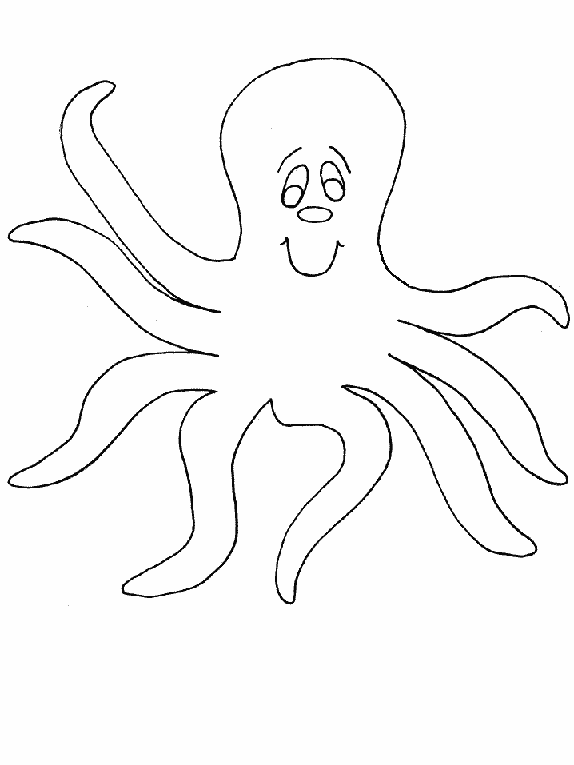 |  |  | 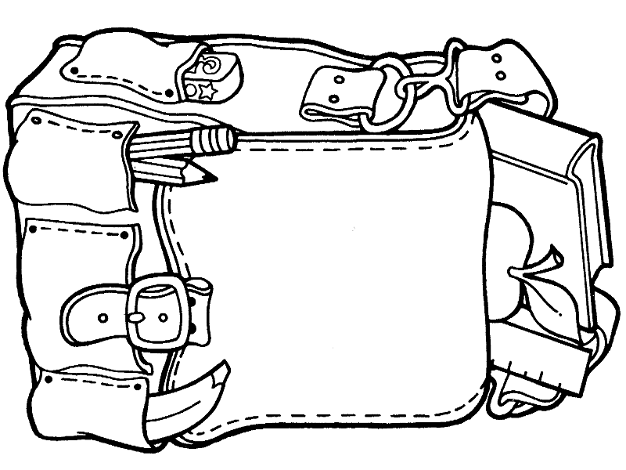 |  |  | Finish

