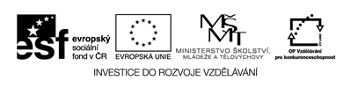

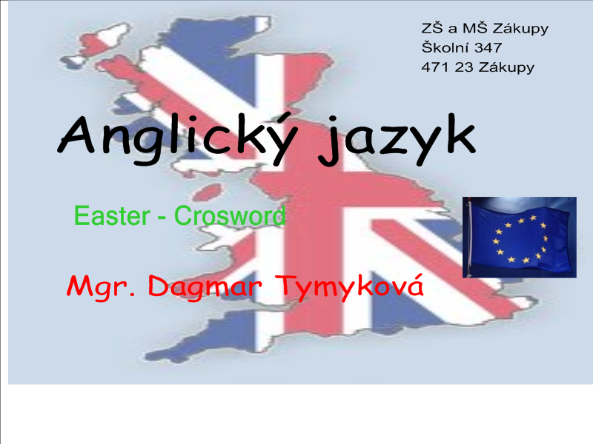

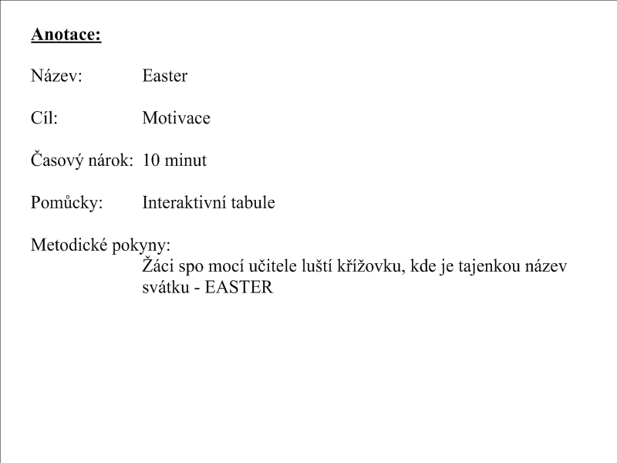

Crosword

|  |  |  |  |  |  |  |  |  |  |  |  |  |  |
| --- | --- | --- | --- | --- | --- | --- | --- | --- | --- | --- | --- | --- | --- |
| http://www.jizni-morava.cz/doc/img/11035.png | | * | * | * | * |  |  |  | p |  |  |  |  |
| http://www.toyotapilotdesigns.com/menubuttons/photo/cat.gif | | * | * | * | c |  |  |
| http://nd01.jxs.cz/819/666/8b3fa215ff_29797819_o2.gif | | * |  | o |  |  |
| http://ephrata1970.files.wordpress.com/2010/03/tiger-41.jpg | | * | * | * | * |  |  |  |  | r |
| http://www.nekuratka.cz/html/images/200x200/kure.obecne.gif | c |  |  |  |  |  | n |
| http://www.predskolaci.cz/wp-content/uploads/2010/03/kralik-s-mrkvickou.gif | | * | * | * | * |  |  |  |  |  |

Nápověda:

Rabbit, hors, chicken, cat, elephant, tyger