

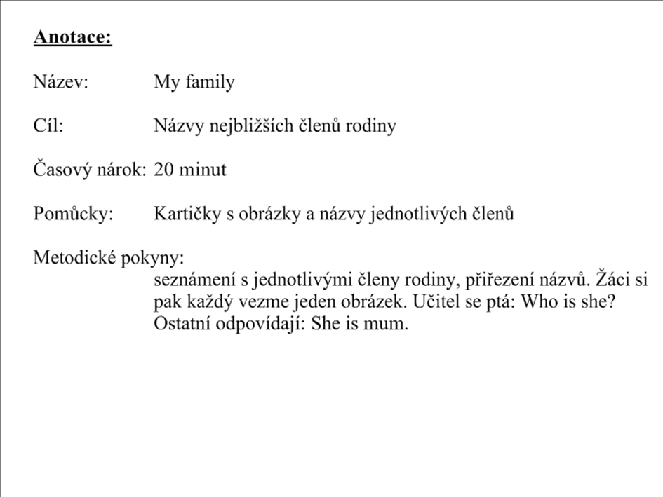

mum

dad

brother

sister

baby

grandad

grandma

[](http://www.google.cz/imgres?imgurl=http://www.klubslunecnice.cz/domain/klubslunecnice/files/maminka.jpg&imgrefurl=http://www.klubslunecnice.cz/schudek-do-skolky/rikadla/&usg=__a09Wsh3IWY4V4pEGs9TXkKNUgP4=&h=1122&w=669&sz=88&hl=cs&start=3&zoom=1&tbnid=Z3GeKOdxhx6YNM:&tbnh=150&tbnw=89&ei=CYfSTY-2EYaPswaLu_DGCQ&prev=/search?q=maminka&hl=cs&biw=884&bih=523&gbv=2&tbs=itp:clipart&tbm=isch&itbs=1)

[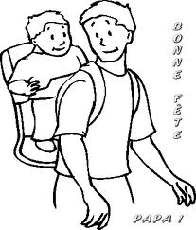](http://www.google.cz/imgres?imgurl=http://nd03.jxs.cz/030/626/f802ca718b_66042378_o2.gif&imgrefurl=http://pourenfants.blog.cz/en/1006&usg=__p7kHKiaFRXeSViPZi-2dxO_siaE=&h=421&w=359&sz=7&hl=cs&start=8&zoom=1&tbnid=wB-uAgu63ve6UM:&tbnh=125&tbnw=107&ei=GYjSTe3NJ9GBswbb5b2nCQ&prev=/search?q=tat%C3%ADnek&hl=cs&sa=X&gbv=2&biw=867&bih=475&tbs=itp:lineart&tbm=isch&itbs=1)

[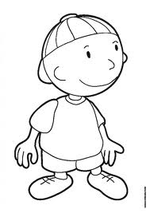](http://www.google.cz/imgres?imgurl=http://www.minikin.sk/obrazky/foto/Chlapec.jpg&imgrefurl=http://www.minikin.sk/?kateg=10&usg=__tgy4hvjWuiAduTuhRvCu-tace4U=&h=900&w=636&sz=44&hl=cs&start=3&zoom=1&tbnid=RTXIQMVP-s-z9M:&tbnh=146&tbnw=103&ei=VIjSTce0IceDswaYsNyjCQ&prev=/search?q=chlapec&hl=cs&gbv=2&biw=867&bih=475&tbs=itp:lineart&tbm=isch&itbs=1)[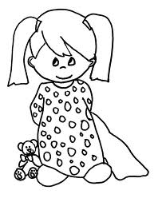](http://www.google.cz/imgres?imgurl=http://www.craftelf.com/Coloring%20Pictures/Free%20coloring%20page%20PJ%20girl.gif&imgrefurl=http://www.craftelf.com/Coloring%20Pages/Craft_elf_Coloring%20Pg_Pj%20Girl.htm&usg=__QRjjGt8wn_Z9kL7XYbOLIzSQ1t4=&h=1329&w=1086&sz=26&hl=cs&start=5&zoom=1&tbnid=WDaYCKaqRrYhIM:&tbnh=150&tbnw=123&ei=hojSTb_zDsTdtAaZzcSpCQ&prev=/search?q=d%C4%9Bv%C4%8De&hl=cs&gbv=2&biw=867&bih=475&tbs=itp:lineart&tbm=isch&itbs=1)

[](http://www.google.cz/imgres?imgurl=http://wiki.rvp.cz/@api/deki/files/17143/=miminko.jpg&imgrefurl=http://wiki.rvp.cz/Kabinet/Obrazky/0.0.0.Kliparty/Postavy&usg=__k6-ktR_rcbiizZUxnr_7WmABR6M=&h=475&w=475&sz=48&hl=cs&start=0&zoom=1&tbnid=jhtW6pvOYqEgnM:&tbnh=137&tbnw=126&ei=pIjSTci5LM31sgbi35C7CQ&prev=/search?q=miminko&hl=cs&gbv=2&biw=627&bih=314&tbs=itp:lineart&tbm=isch&itbs=1&iact=rc&dur=406&page=1&ndsp=10&ved=1t:429,r:2,s:0&tx=64&ty=93)[](http://www.google.cz/imgres?imgurl=http://preview.canstockphoto.com/canstock5425305.png&imgrefurl=http://www.canstockphoto.cz/d%C4%9Bde%C4%8Dek-5425305.html&usg=__wKYLhRFbOQqAK3JW4Z5D2qPXE-s=&h=296&w=225&sz=57&hl=cs&start=5&zoom=1&tbnid=iaKYWqfiJXiSYM:&tbnh=116&tbnw=88&ei=2YjSTcPuEYbOswbSiv27CQ&prev=/search?q=d%C4%9Bde%C4%8Dek&hl=cs&gbv=2&biw=867&bih=474&tbs=itp:lineart&tbm=isch&itbs=1)

[](http://www.google.cz/imgres?imgurl=http://wiki.rvp.cz/@api/deki/files/17031/=babi%25c4%258dka.jpg&imgrefurl=http://wiki.rvp.cz/index.php?title=Kabinet/Obrazky/0.0.0.Kliparty/Postavy&galleryOffset=12&usg=__GWcBvgfReNskR-9QCweleDZ4XAE=&h=475&w=332&sz=43&hl=cs&start=1&zoom=1&tbnid=3aEtoxuUgpBoBM:&tbnh=129&tbnw=90&ei=9ojSTdOZFcqCswbny_m-CQ&prev=/search?q=babi%C4%8Dka&hl=cs&gbv=2&biw=867&bih=475&tbs=itp:lineart&tbm=isch&itbs=1)