

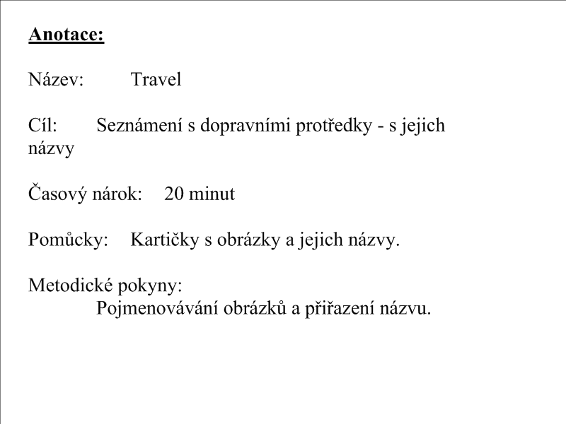

car

bus

train

bike

ship

rocket

motorbike

plane

[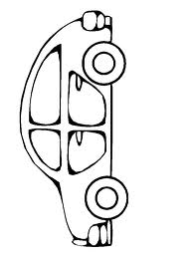](http://www.google.cz/imgres?imgurl=http://www.detskeomalovanky.cz/wp-content/auto5.gif&imgrefurl=http://www.detskeomalovanky.cz/600/rodinne-auto/&usg=__FIFPN1l2aMLaOJDPQbn1avyAT4M=&h=957&w=718&sz=11&hl=cs&start=1&zoom=1&tbnid=52dZLZlWiNuuxM:&tbnh=148&tbnw=111&ei=rHPSTfvuLcrZsgbR2am_CQ&prev=/search?q=auto&hl=cs&sa=X&biw=884&bih=523&gbv=2&tbs=itp:lineart&tbm=isch&itbs=1)

[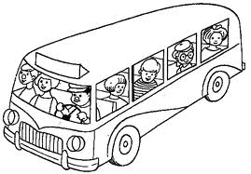](http://www.google.cz/imgres?imgurl=http://www.canalred.info/public/Plantillas_Colorear/Transportes/Autobus/Autobus-01.gif&imgrefurl=http://www.canalred.info/public/Plantillas_colorear/index.php?d=Transportes/Autobus&usg=__wNjlmeDBbMlra11t6HwXbuTU7oM=&h=418&w=600&sz=15&hl=cs&start=1&zoom=1&tbnid=SZnv_OSGhPjHGM:&tbnh=94&tbnw=135&ei=BHTSTaGIC8jUsgatrsWnCQ&prev=/search?q=autobus&hl=cs&gbv=2&biw=867&bih=474&addh=36&tbs=itp:lineart&tbm=isch&itbs=1)

[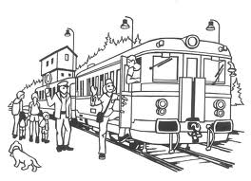](http://www.google.cz/imgres?imgurl=http://wiki.rvp.cz/@api/deki/files/9901/=vlaky02.jpg&imgrefurl=http://wiki.rvp.cz/Kabinet/Obrazky/0.0.0.Kliparty/Dopravn%C3%AD_prost%C5%99edky_a_lid%C3%A9&usg=__Q0rQJfvIpazrNbOcnBkGhYO7-ng=&h=868&w=1200&sz=206&hl=cs&start=3&zoom=1&tbnid=i_5zie9w6l_8WM:&tbnh=109&tbnw=150&ei=dnTSTd6hJY3GtAb0zvnGCQ&prev=/search?q=vlak&hl=cs&biw=867&bih=474&gbv=2&tbs=itp:lineart&tbm=isch&itbs=1)

[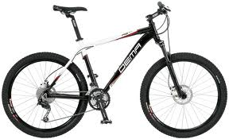](http://www.google.cz/imgres?imgurl=http://www.jizdnikola.net/files/horske-kolo-dema-asti-model-2010.jpg&imgrefurl=http://www.jizdnikola.net/?2953,horske-kolo-dema-asti-model-2010&usg=__3cONLSMLQyH2TG2k6tBhWW-mtZY=&h=485&w=800&sz=166&hl=cs&start=3&zoom=1&tbnid=DK4zvWYzdBYsNM:&tbnh=87&tbnw=143&ei=lXTSTbv9MsnPtAbS08yeCQ&prev=/search?q=kolo&hl=cs&gbv=2&biw=867&bih=475&output=images_json&tbs=itp:lineart&tbm=isch&itbs=1)

[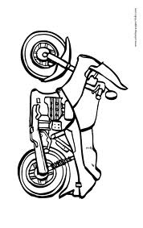](http://www.google.cz/imgres?imgurl=http://www.coloring-pages-kids.com/coloring-pages/transportation-coloring-pages/motorcycles-coloring-pages/motorcycles-coloring-pages-images/motorcycle-coloring-page-06.gif&imgrefurl=http://www.coloring-pages-kids.com/coloring-pages/transportation-coloring-pages/motorcycles-coloring-pages/motorcycles-coloring-pages-images/motorcycle-coloring-page-06.php&usg=__nJgaN5-cmgelSDJn90BYU_cc6jw=&h=875&w=552&sz=19&hl=cs&start=8&zoom=1&tbnid=kCLBAcem_BprnM:&tbnh=146&tbnw=92&ei=w3TSTen-DMPHswb9lL2eCQ&prev=/search?q=motorka&hl=cs&biw=867&bih=475&gbv=2&tbs=itp:lineart&tbm=isch&itbs=1)

[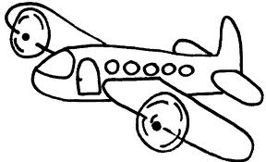](http://www.google.cz/imgres?imgurl=http://www.nicoles-funworld.de/windowcolor/Malvorlagen/flugzeug/flugzeug_01.gif&imgrefurl=http://colorbow.blog.cz/0808/omalovanky-letadla&usg=__wDoZ7YIbP84S3rTjDBZ4J5OTz1w=&h=404&w=663&sz=7&hl=cs&start=6&zoom=1&tbnid=K9w9fZeRb7jviM:&tbnh=84&tbnw=138&ei=FXXSTf7eAYTatAaC2vyiCQ&prev=/search?q=letadlo&hl=cs&biw=867&bih=475&gbv=2&tbs=itp:lineart&tbm=isch&itbs=1)

[](http://www.google.cz/imgres?imgurl=http://www.mestizaminx.cz/userFiles/raketa1.jpg&imgrefurl=http://www.mestizaminx.cz/raketa---audio&usg=__XXMCF0c0SZw6Qag4YA56tCAjYEU=&h=598&w=800&sz=143&hl=cs&start=1&zoom=1&tbnid=lsFClYfDuL7qKM:&tbnh=107&tbnw=143&ei=PXXSTa-jCInNtAas4rCnCQ&prev=/search?q=raketa&hl=cs&biw=627&bih=314&gbv=2&tbs=itp:lineart&tbm=isch&itbs=1)

[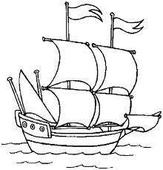](http://www.google.cz/imgres?imgurl=http://janoch.borec.cz/omal_2/1_lod.gif&imgrefurl=http://janoch.borec.cz/omal_2/omalovanky.html&usg=__eoMYHO6zpjf9r9z_NfvLspV6HWQ=&h=698&w=670&sz=11&hl=cs&start=0&zoom=1&tbnid=YD3xwR1W9ON5SM:&tbnh=148&tbnw=142&ei=snXSTdXpM9HLsgbeovjCCQ&prev=/search?q=lo%C4%8F&hl=cs&biw=867&bih=474&gbv=2&tbs=itp:lineart&tbm=isch&itbs=1&iact=rc&dur=550&page=1&ndsp=9&ved=1t:429,r:2,s:0&tx=86&ty=97)