

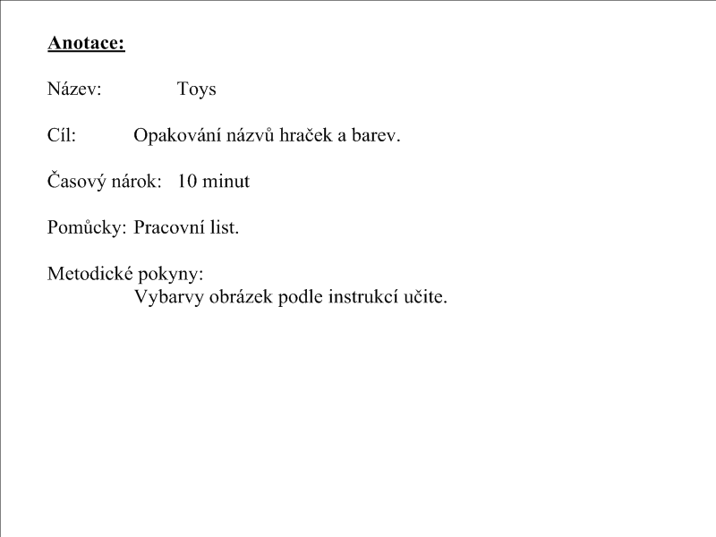

[](http://www.google.cz/imgres?imgurl=http://www.supercoloring.com/wp-content/thumbnail/2008_12/doll-coloring-page.jpg&imgrefurl=http://www.supercoloring.com/pages/category/people/gender/&usg=__rJRFn5s6UyvUccxyUpj0L195_Zs=&h=360&w=257&sz=37&hl=cs&start=3&zoom=1&tbnid=yBZzz6fD9FrpQM:&tbnh=121&tbnw=86&ei=ARPRTdSSDY7ItAbs9MDGCw&prev=/search?q=panenka&hl=cs&gbv=2&biw=867&bih=474&tbs=itp:lineart&tbm=isch&itbs=1)

[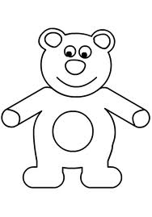](http://www.google.cz/imgres?imgurl=http://wiki.rvp.cz/@api/deki/files/16969/=medv%25c3%2583%25c2%2583%25c3%2582%25c2%2583%25c3%2583%25c2%2582%25c3%2582%25c2%2583%25c3%2583%25c2%2583%25c3%2582%25c2%2582%25c3%2583%25c2%2582%25c3%2582%25c2%2584%25c3%2583%25c2%2583%25c3%2582%25c2%2583%25c3%2583%25c2%2582%25c3%2582%25c2%2582%25c3%2583%25c2%2583%25c3%2582%25c2%2582%25c3%2583%25c2%2582%25c3%2582%25c2%259bd.jpg&imgrefurl=http://wiki.rvp.cz/index.php?title=Kabinet/Obrazky/0.0.0.Kliparty/Zv%C3%AD%C5%99ata&galleryOffset=18&usg=__hEupnwuOmoG0oqcPf-Ss5FSlvMY=&h=475&w=332&sz=40&hl=cs&start=4&zoom=1&tbnid=v-fuyi7gf1wBkM:&tbnh=129&tbnw=90&ei=SxPRTciSLoKCswaB17SrCw&prev=/search?q=medv%C4%9Bd&hl=cs&gbv=2&biw=867&bih=475&tbs=itp:lineart&tbm=isch&itbs=1)

[](http://www.google.cz/imgres?imgurl=http://www.index.hr/images2/lopta000V.jpg&imgrefurl=http://www.index.hr/xmag/clanak/humane-zvijezde-vracaju-se-u-akciju/340255.aspx&usg=__VAYqsQDw-QwNSwMrUSipb4SD_xU=&h=293&w=293&sz=13&hl=cs&start=10&zoom=0&tbnid=Wnh4tq4XdFj5gM:&tbnh=115&tbnw=115&ei=cxPRTey2LYfXtAb-v82dCw&prev=/search?q=m%C3%AD%C4%8D&hl=cs&gbv=2&biw=867&bih=475&tbs=itp:lineart&tbm=isch&itbs=1)

[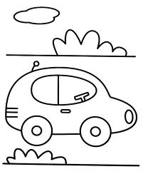](http://www.google.cz/imgres?imgurl=http://www.omalovanky.biz/omalovanky/auta/omalovanka-auto.gif&imgrefurl=http://www.omalovanky.biz/omalovanka.html?kategorie=auta&omalovanka=auto&usg=__oUOuTu3fWvsPB5EKLJ2c9d2OpAw=&h=709&w=567&sz=19&hl=cs&start=6&zoom=1&tbnid=RCd1UX1n7jmjKM:&tbnh=140&tbnw=112&ei=ChTRTbnnOcjStAap14TECw&prev=/search?q=auto&hl=cs&gbv=2&biw=867&bih=475&tbs=itp:lineart&tbm=isch&itbs=1)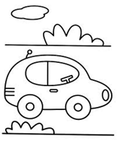

[](http://www.google.cz/imgres?imgurl=http://nehudek.wz.cz/cedule/letadlo.gif&imgrefurl=http://nehudek.wz.cz/index2.php?id=15&usg=__ObJjkklJ6gO5Y_7z1o9ZbBKNaXQ=&h=822&w=822&sz=10&hl=cs&start=8&zoom=1&tbnid=snOiUhUC28Tf5M:&tbnh=144&tbnw=144&ei=WxTRTd3OEoHUtAa01ZW4Cw&prev=/search?q=letadlo&hl=cs&gbv=2&biw=867&bih=475&tbs=itp:lineart&tbm=isch&itbs=1)

[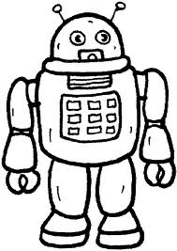](http://www.google.cz/imgres?imgurl=http://www.zerboni.com/educational/Giocattoli%2002/robot%202.gif&imgrefurl=http://www.zerboni.com/educational/Giocattoli%2002/disegni.php&usg=__ONJ3AF7Mdk8TzClvOVukBh8rju0=&h=600&w=425&sz=9&hl=cs&start=1&zoom=1&tbnid=moVI77BpOSpaKM:&tbnh=135&tbnw=96&ei=lhTRTaioINHDswaKlMCtCw&prev=/search?q=robot&hl=cs&gbv=2&biw=867&bih=475&tbs=itp:lineart&tbm=isch&itbs=1)