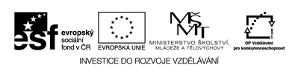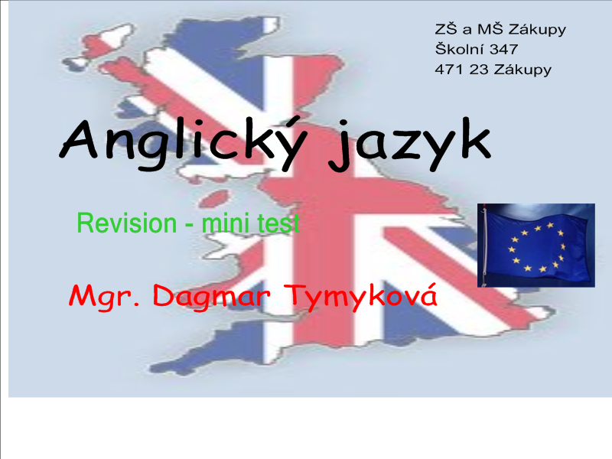

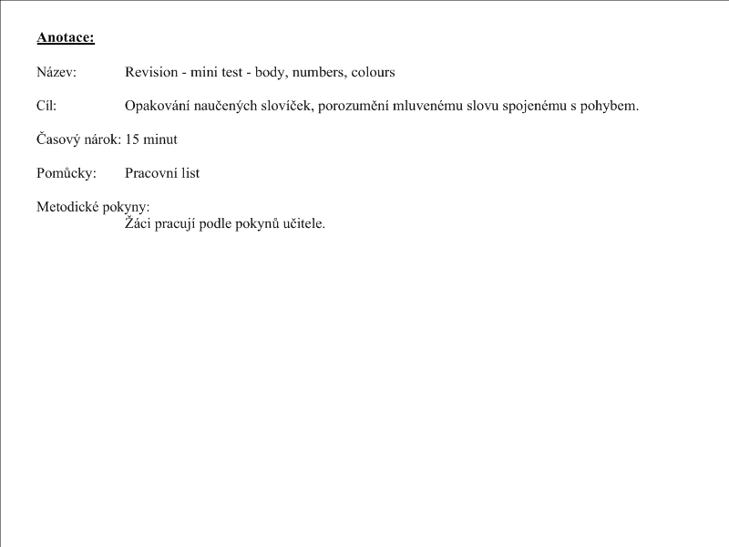

- Take pencil and draw.
Two apples | Eight eyes | One ice cream
Ten pencils | Five chairs | Nine noses
Three legs | Two windows | One teacher

- My monster – one big head, green long hair, ten blue eyes, two black mouth, three oranges noses and six ears.

