

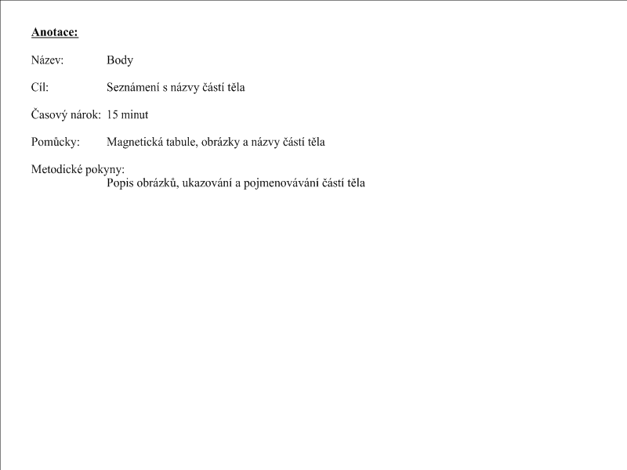

body

arm

leg

head

hand

ear

eye

body

foot

mouth

nose

[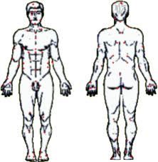](http://www.google.cz/imgres?imgurl=http://www.karateklikar.ic.cz/userfiles/image/telo.gif&imgrefurl=http://www.karateklikar.ic.cz/ruzne/telo&usg=__g5-KfYdWzQAHCIGlbewegD5al_4=&h=308&w=301&sz=30&hl=cs&start=1&zoom=1&tbnid=REcPi9OGIwO6SM:&tbnh=117&tbnw=114&ei=EUnJTfaLNsLs-gbrxuT7BQ&prev=/search?q=t%C4%9Blo&hl=cs&sa=X&biw=884&bih=523&gbv=2&tbs=itp:clipart&tbm=isch&itbs=1)

[](http://www.google.cz/imgres?imgurl=http://mobilnizabava.wz.cz/obrazky/ruzne/pusa.jpg&imgrefurl=http://mobilnizabava.wz.cz/dalsiruz.htm&usg=__grbwL1zVpaakUPkIETCyDJNV-Pk=&h=128&w=128&sz=4&hl=cs&start=6&zoom=0&tbnid=8N4A3TnWadOhBM:&tbnh=91&tbnw=91&ei=U0rJTYa7L4GA-waz5-SABg&prev=/search?q=pusa&hl=cs&sa=X&biw=884&bih=523&gbv=2&tbs=itp:clipart&tbm=isch&itbs=1) [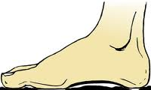](http://www.google.cz/imgres?imgurl=http://www.medicolux.net/db/wysiwyg/Image/detox/noha.png&imgrefurl=http://www.medicolux.net/meedp-3/meedp/&usg=__241N2VOEySZQyQRlNc-qPZAp8pM=&h=150&w=250&sz=21&hl=cs&start=78&zoom=1&tbnid=F10_GWDypXnszM:&tbnh=120&tbnw=200&ei=-ErJTZiXPMSp8QPQ46DWBg&prev=/search?q=noha&hl=cs&biw=884&bih=523&gbv=2&tbs=itp:clipart&tbm=isch&itbs=1&iact=rc&dur=452&page=10&ndsp=8&ved=1t:429,r:7,s:78&tx=84&ty=81)

[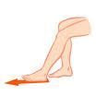](http://www.google.cz/imgres?imgurl=http://www.varixinal.cz/img/cvik-1.gif&imgrefurl=http://www.varixinal.cz/gymnastika-pro-zdrave-nohy/&usg=__aORkiM9virDNnIPm8C69BTVTgo0=&h=200&w=200&sz=3&hl=cs&start=2&zoom=0&tbnid=3agW_odwljDbFM:&tbnh=104&tbnw=104&ei=qkvJTa_NM8a3-wbm_tX5BQ&prev=/search?q=doln%C3%AD+kon%C4%8Detina&hl=cs&sa=X&gbv=2&biw=867&bih=475&addh=36&tbs=itp:clipart&tbm=isch&itbs=1)

[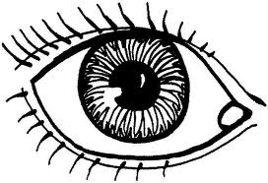](http://www.google.cz/imgres?imgurl=http://www.terescinotvoreni.wz.cz/oko.JPG&imgrefurl=http://www.terescinotvoreni.wz.cz/lidske-telo.htm&usg=__vxEoeeueTx3h2DcdsD_YoSDlIyc=&h=491&w=718&sz=70&hl=cs&start=2&zoom=1&tbnid=hI5oh34guO4rxM:&tbnh=96&tbnw=140&ei=BEzJTZy1McXQ-gaM_9n4BQ&prev=/search?q=oko&hl=cs&gbv=2&biw=867&bih=475&tbs=itp:clipart&tbm=isch&itbs=1)

[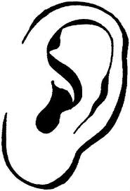](http://www.google.cz/imgres?imgurl=http://www.terescinotvoreni.wz.cz/ucho.JPG&imgrefurl=http://www.terescinotvoreni.wz.cz/lidske-telo.htm&usg=__bxTRKd57hCH7ixMSuRpGFw8Oh60=&h=652&w=443&sz=29&hl=cs&start=1&zoom=1&tbnid=J_a3fgRla6X-SM:&tbnh=138&tbnw=94&ei=IEzJTaK2H4Lt-gbUrdmABg&prev=/search?q=ucho&hl=cs&gbv=2&biw=867&bih=475&tbs=itp:clipart&tbm=isch&itbs=1)

[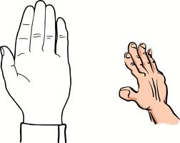](http://www.google.cz/imgres?imgurl=http://files.daggy.webnode.cz/200000013-1b0d11c06b/ruka.jpg&imgrefurl=http://www.daggy.webnode.cz/&usg=__M4cF2XFHQKLijInT_PoBK0nfiAY=&h=667&w=840&sz=37&hl=cs&start=1&zoom=1&tbnid=FL6A1647P_UEpM:&tbnh=115&tbnw=145&ei=OkzJTfnoHI2G-wacw6TkBQ&prev=/search?q=ruka&hl=cs&gbv=2&biw=867&bih=475&tbs=itp:clipart&tbm=isch&itbs=1)

[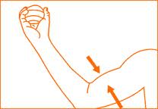](http://www.google.cz/imgres?imgurl=http://elife.cz/gfx/Image/vyrobky/Powerball/posilujeme%20biceps.gif&imgrefurl=http://elife.cz/shop/powerball/info/cviky/&usg=__-tj6B4l_0lkB2gfAHd6JI3rZqkw=&h=180&w=260&sz=3&hl=cs&start=8&zoom=1&tbnid=1kLcuUsi1aOVeM:&tbnh=78&tbnw=112&ei=kkzJTauCO4rt-gb7zNjaBQ&prev=/search?q=pa%C5%BEe&hl=cs&gbv=2&biw=867&bih=475&tbs=itp:clipart&tbm=isch&itbs=1)

[](http://www.google.cz/imgres?imgurl=http://www.agencyforyou.cz/obrazky/B-hlava.jpg&imgrefurl=http://www.agencyforyou.cz/jine.htm&usg=__nmSyG3i_A0zITEbrupa7gSw2j-Y=&h=191&w=199&sz=9&hl=cs&start=8&zoom=1&tbnid=SRjcMYWIzJzdPM:&tbnh=100&tbnw=104&ei=6EzJTYe-HM-G-wa1pLX6Ag&prev=/search?q=hlava&hl=cs&gbv=2&biw=867&bih=475&tbs=itp:clipart&tbm=isch&itbs=1)

[](http://www.google.cz/imgres?imgurl=http://wiki.rvp.cz/@api/deki/files/17837/=nos.jpg&imgrefurl=http://wiki.rvp.cz/Kabinet/Obrazky/0.0.0.Kliparty/T%C4%9Blo/Smysly&usg=__-ZTmyB5xt26kC-z9owIpMZIQ4BY=&h=781&w=549&sz=12&hl=cs&start=4&zoom=1&tbnid=QXxq-uObbLqlpM:&tbnh=143&tbnw=101&ei=Ck3JTZXoB4uf-Qa98dXgBQ&prev=/search?q=nos&hl=cs&gbv=2&biw=867&bih=475&tbs=itp:clipart&tbm=isch&itbs=1)