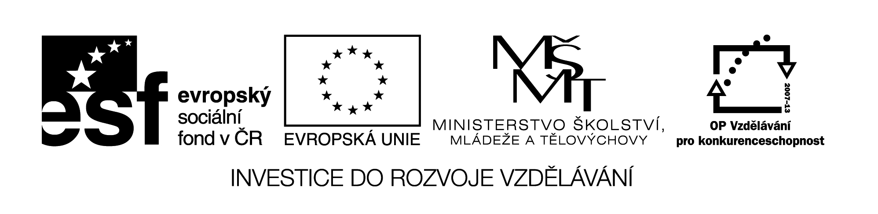
EU II-2 AJ7
Šárka Kamenská
ZŠ Zákupy
Název: Vstupní test
Cíl: Opakování učiva 6. ročníku
Čas: 20 min.
Pomůcky:
Popis aktivity:
Dle pokynů v zadání žáci doplní do testu gramatické jevy.

…........................................
name
VSTUPNÍ TEST

- COMPLETE THE SENTENCES IN PRESENT SIMPLE

I 1…........................... (live) on a farm in Scotland with my mum and dad and my litlle sister

Becky. Every day we 2...................................(take) the bus to school. We 3.......................................

…......................(not come) back before four o´clock. My sister 4....................................................

(play) the piano but I 5............................................................(not play) a musical instrument.
….............../5

- COMPLETE THE SENTENCES IN PRESENT CONTINOUS.

1) In this picture Jane ….................................................(play) football with her friends.

2) I ….................................................................(not watch) TV now.

3) ….................... they ….................................(do) their homework at the moment?

4) …................ Pedro …...........................(write) a letter now?

5) Molly …........................................................(not listen) to music now.
…............/5

- CHOOSE THE CORRECT TENSE, DELETE THE INCORRECT ONE.

- I´m on holiday now. I have / am having a great time.

- I send / ´ m sending an e-mail to my penfriend every week.

- Every summer we go / are going to Scotland.

- Jane plays / is playing a computer game at the moment.

- „Hello. Is John in?“
„Yes, he watches / is watching TV."
….........../5

- COMPLETE some OR any.

1) I need …......................................... money.

2) We haven´t got …............................................. apples.

3) Have you got …................................... Aqua Cds?

4) I´m writing …................................ letters.

5) I don´t play …...................................... sports.
…............/5

- CHOOSE THE CORRECT PRONOUN TO COMPLETE THE SENTENCES.

1)...........................´re going to the shops. (we/us)

Do you want to come with …...............................? (we/us)

2) No, ….................................... isn´t. (she/her) Her father is taking ….......................... to her

dance class. (she/her)

3) ….................´s in the garden. (he/him) …........................ (I/me) can´t see …..................(he/him)
…........../7

- ANSWER THE QUESTIONS.

- Where are you from?

…...........................................................................................................................................................
- Where do you live?

…...........................................................................................................................................................
- What does your father do?

…...........................................................................................................................................................
- What is your favourite school subject?

…...........................................................................................................................................................
- What do you do in your free time?

…...........................................................................................................................................................
- Have you got a pet?

…..........................................................................................................................................................
- When is your birthday?

…...........................................................................................................................................................
- Have you got any brothers or sisters?

…...........................................................................................................................................................
…............/8

TOTAL :.........................../35

