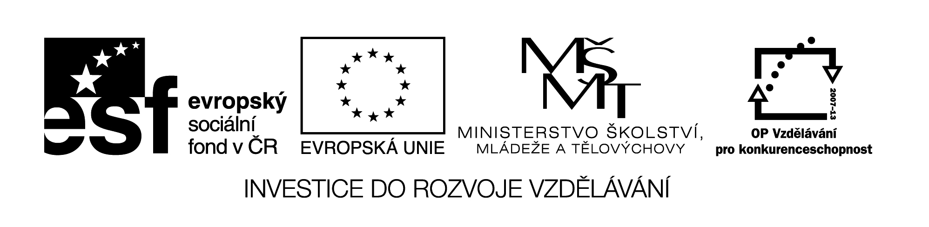
EU II-2 AJ6
Šárka Kamenská
ZŠ Zákupy
Název: Vstupní test
Cíl: Opakování učiva 5. ročníku
Čas: 20 min.
Pomůcky:
Popis aktivity:
Dle pokynů v zadání žáci doplní do testu gramatické jevy.

…......................................
name
VSTUPNÍ TEST 6
- COMPLETE am, is, are.

1) They ….......................... in London.

2) Courtney ….................. from the USA.

3) I …................ at the door.

4) …................ you on holiday?

5) This postcard ….............. from Tony.
…........./5

- COMPLETE THE SENTENCES WITH his, her, their, he´s, she´s, they´re.

1) This is Jane. ….................. from London. …........................ twelve. Bruce is …............ dog.

2) Where´s Ben? …................ in the garden with …............ friends.

3) There´s Mrs Smith with …............... three dogs. …............. all black.

4) This is a photo of Courtney with …............... mum and dad. …........... in …............ garden.
….........../10

- WRITE THE NUMBERS

27............................................................ 32...........................................................................

12............................................................ 100..........................................................................

55............................................................ 49...........................................................................

18............................................................ 15...........................................................................

14............................................................ 71...........................................................................
…........../10
WRITE THE PLURALS

a chair – 2 …...................................... a man – 3 ….......................................................

a child – 5 …...................................... a watch – 2 …....................................................

a mouse – 4........................................ a foot – 2 ….......................................................

a table – 3 …...................................... an orange – 4 …................................................

a woman -3 ….................................... a box – 2 …......................................................
…............/10

- COMPLETE have got OR has got.

1) They …................................. a new car.

2) Jane …...................................a pet.

3) ….................. you ….............. Science on Monday?

4) We …................................ a poster.

5)........................ Courtney ….................. a cat?
…............./5

- COMPLETE THE CORRECT FORM OF THE VERB.
HAVE, GO, WATCH, READ, GET

1) Becky …...................... books in bed.

2) I …...................... breakfast in the kitchen.

3) At weekends Tony and Jane …................... to bed at 11 o´clock.

4) My brother …............................. up at 6 o´clock.

5) My mum and dad ….......................... TV from 8 to 10 o´clock.
…........../5

- WRITE THE QUESTIONS, COMPLETE do OR does.

1) When ….................... you go home?

2) ….................... Tony play the quitar?

3) Where …...................... Jane do her homework?

4) When …....................... Mandy and Ben go to school?

5) …..................... they have lunch at school?
…........./5

TOTAL ….............../ 50

